**Popcorn Kernel Pop Times When Soaked in Different Liquids**

Ryan DeStefano, Statistics, California Polytechnic State University

Cole Yant, Statistics, California Polytechnic State University

1. Introduction

(*This is where you should describe your research question/goals and motivation. Your motivation should address why you are interested in the answers to your research question, and why the reader should be interested in your research. You should also cite at least two other research articles or articles in popular media that are related to your research question. Discuss how the content of these articles is similar and/or different from what your study is about. Did you have an interest in finding which treatment combination is “best”? What did you expect to find? You should break this section up into at least 2 or 3 paragraphs.*)

2. Materials and Methods

Experimental units, kernels, were obtained from a singular bag of popcorn kernels. Other materials needed for the experiment include water, vinegar, paper towels, and a microwave (or other equivalent heating source). One repetition consisted of soaking a single popcorn kernel (randomly chosen from the bag of kernels) in one of the liquids (water vinegar or no liquid) for 5 seconds then immediately putting it onto a paper towel and into the microwave. Once the kernel was in the microwave, the microwave was set to 30 minutes and when start was pressed, a stopwatch was simultaneously started. Once the kernel popped, the stopwatch was stopped and the time on the watch was recorded in seconds. This process was repeated for a total of 30 times, 10 times per treatment. Potential measurement issues include human error, meaning the starting and stopping of the stopwatch was not done simultaneously with the starting of the microwave and popping of the kernel. This, however, is not a huge issue because this error is very small (most likely less than half a second).

2.1 Treatment Structure

A one-way treatment structure at 3 levels was used for the experiment. The factor of interest was type of liquid with three levels (nominal): no liquid, water, and vinegar. These levels were chosen because a common practice when cooking popcorn is to splash water on the bag or kernels; and vinegar was chosen to bring in a new method that could possibly affect the pop time.

2.2 Response Variable(s)

The response variable, pop time, was measured in seconds using a stopwatch. No specific range of values of pop time was expected or wanted during the study.

2.3 Experimental Unit

Each popcorn kernel. Each kernel came from a singular bag of white popcorn kernels.

2.4 Design Structure

A completely randomized design structure was used with 10 repetitions per treatment. Treatments were randomly assigned to each kernel with JMP, using the Full Factorial Design method. Replication was used in the experiment because there were 10 repetitions per treatment level. This number of repetitions was chosen because it yields an overall sample size of 30 which is relatively large.

2.5 Dealing with other sources of variation

Some extraneous sources of variation include human error, wattage of the microwave, warmth of the object the kernel is put on in the microwave, and how well the kernel is coated with the liquid. These sources of variation were controlled by having the same person start and stop the stopwatch, keeping the microwave at the same power level (wattage), putting the kernel on a new paper towel each repetition, and soaking the kernel for the same amount of time (5 seconds) for each repetition. Randomization of run order was also used to tackle any other sources of variation not accounted for. This was done by going in the order specified in the JMP Full Factorial Design method (as described in “2.4 Design Structure”)

2.6 Statistical model and data analysis

Effects Model: yij = 𝝁 + 𝜶i + 𝜺ij

yij represents the pop time of the jth kernel in the ith treatment group. 𝝁 represents the mean pop time of the whole sample (n = 30). 𝜶i represents the effect of the ith treatment. 𝜺ij (random errors) = N(0, 𝝈2), represents the individual distance from the mean + effect of the jth kernel in the ith treatment. The subscript, i, takes values 1 through 3 and the subscript, j, takes values 1 through 10.

Assumptions made by the model:

* Random errors are independent of each other.
* Random errors are normally distributed.
* Random errors have equal variance.

JMP (Version 15.1.0) was then used to run an ANOVA test with a FWER equal to .05 on the following hypotheses:

Ho: 𝜶NoLiquid = 𝜶Water = 𝜶Vinegar

Ha: At least one of the effects is different

An ANOVA test was used because we want to know if type of liquid a popcorn kernel is soaked in effects pop time.

3. Analysis and Results

3.1 Descriptive statistics

**Table 3.1 Mean pop time for each of the 3 treatments**

|  |  |  |
| --- | --- | --- |
| Level | N | Mean |
| None | 10 | 70.208 |
| Water | 10 | 90.399 |
| Vinegar | 10 | 127.601 |

An initial look at the treatment means as seen in table 3.1 reveals that at least one of the treatment means appears to be different. Each of the mean pop times differs by at least 20 seconds. This means that the treatment effects are possibly different.

**Figure 3.1 Side-by-side boxplots showing how pop time changed with changes in type of liquid the kernel was soaked in**

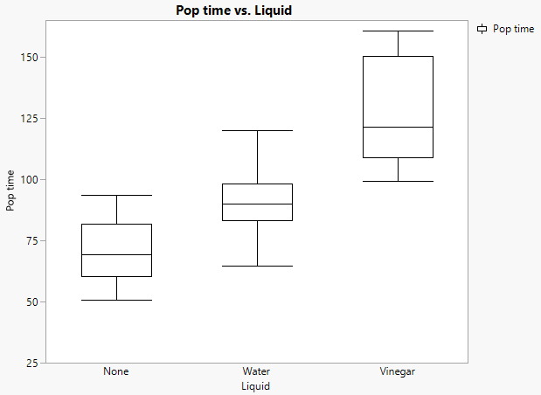

As seen in figure the 3.1, the boxplots of pop time grouped by type of liquid do not have much overlap. Also, the difference between group means is larger than within group variance. This strongly suggests that at least one of the pop time means differs. It appears that the no liquid group has the shortest pop time, water group second, and vinegar group third.

3.2 Inferential findings

**Table 3.2.1 ANOVA output**

|  |  |  |  |  |  |
| --- | --- | --- | --- | --- | --- |
| Source | DF | Sum of Squares | Mean Square | F -Ratio | Prob >F |
| Liquid | 2 | 16952.07 | 8476.04 | 29.06 | <.0001 |
| Error | 27 | 7875.13 | 291.67 |  |  |
| Total | 29 | 24827.21 |  |  |  |

As seen from table 3.2.1, there is very strong evidence at the 5% significance level (p-value < .0001) that one of the treatment effects differs from the others. Since treatments were randomly assigned to experimental units, we can draw a cause-and-effect relationship between type of liquid and pop time. These results can be generalized to those popcorn kernels like those used in the study (white popcorn kernels).

The independence assumption is satisfied because a random sample of kernels was taken from the bag of kernels.

**Table 3.2.2 Unequal Variance Test**

|  |  |  |  |  |
| --- | --- | --- | --- | --- |
| Test | F-Ratio | DFNum | DFDen | Prob > F |
| Levene | 2.97 | 2 | 27 | .068 |

The equal variance assumption is satisfied because there is no evidence that the random errors have unequal variances as seen in table 3.2.2, where the Levene test results in a p-value of .068 which is more than .05.

**Table 3.2.3 Shapiro Wilk Test**

|  |  |
| --- | --- |
| W | Prob < W |
| .949 | .168 |

The normality assumption is satisfied because as seen in table 3.2.3, there is no evidence to suggest that the random errors are not Normally distributed because the Shapiro Wilk Test results in a p-value that is greater than .05.

**Table 3.2.4 Letters Plot**

|  |  |
| --- | --- |
| Level | Letter |
| Vinegar | A |
| Water | B |
| None | C |

Note: Levels that share a letter have means that are not statistically significantly different.

**Table 3.2.5 Ordered Differences Report**

|  |  |  |  |  |  |
| --- | --- | --- | --- | --- | --- |
| Level | -Level | Difference | Lower CL | Upper CL | p-value |
| Vinegar | None | 57.39 | 38.46 | 76.33 | <.0001 |
| Vinegar | Water | 37.2 | 18.26 | 56.14 | .0001 |
| Water | None | 20.19 | 1.25 | 39.13 | .0349 |

Since there is at least one treatment effect that differs from the others, further investigation must be done. This investigation was done with the tukey test comparing means individually to each other (two at a time). Tables 3.2.4 and 3.2.5 are output from this test. As seen in table 3.2.4, since none of the treatments have the same letter, all the treatment means differ from each other. This fact is further emphasized in the ordered differences report (table 3.2.5), This report gives information on the confidence intervals between the difference in pop times between each combination of treatments. None of these intervals contain 0 so this means that all the pop times differ from group to group.

4. Conclusion

(*In this section, you will provide the main findings of your study – one more time. This time you do not need to provide all the numbers to support your findings, but more “big picture” conclusions. For example, “we found strong evidence that helicopters with 3inch wing length have a higher average flight time than those with 2inch wing length.” Etc. This is your last opportunity to make sure your reader understands your take-home message. Which treatment combination was “best”? Which treatment had the largest effect? Smallest? Answer all of your research questions one more time.)*

5. Next steps

*(In this section you will provide suggestions to improve the study if it were run again. Were there issues you would address if the experiment was done again? Variables which should have been controlled, but were not? Data collection issues that caused problems? Etc.)*.

*(What would be an interesting follow-up experiment? This experiment should have sparked some interest in future research. Provide at least one example of a direction that others could go to follow-up on what you’ve already done.*

References

(Please verify that all references are included. Especially the ones you were asked to include in the Introduction. If it’s a weblink, include the date the link was last accessed.)

* Author names (year of publication), “Name of article” *Journal name,* volume, pages …
* Author names (year of publication), “Name of article” *Journal name,* volume, pages …

**Appendix**

Randomization scheme

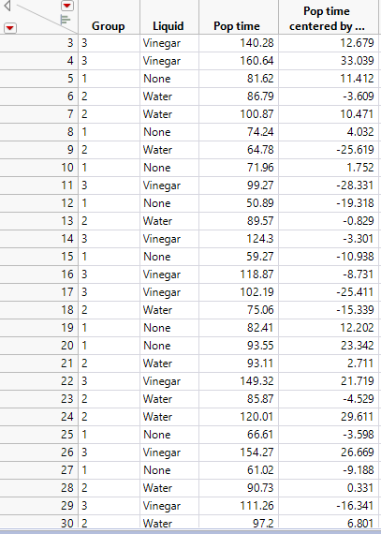

ANOVA output

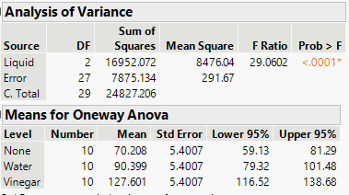

Tukey test

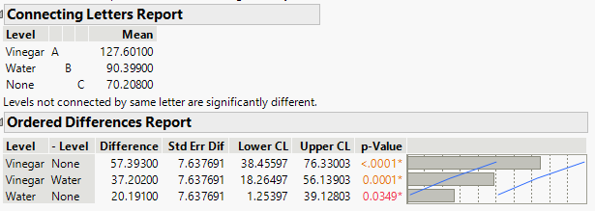

Levene test

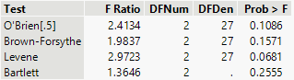

Shapiro Wilk test

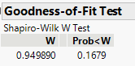

Boxplots

